2026-2027 Pre-K Supply List
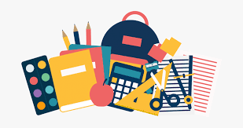
• Backpack (regular size)
• Extra set of clothing (including shoes, socks, and underwear) labeled with child’s name in a zip-lock bag.
• Small Blanket or Towel (labeled with child’s name)
• Water Bottle (labeled with child’s name)
• 1 box Crayola crayons (24 pack)
• 1 box washable markers (12 pack)
• 1 pack thick Expo markers
• 1 pencil box
• 1 plastic folder with pockets and 3 prongs
• 2 plastic folders with pockets
• 2 boxes of tissues
• 2 rolls of paper towels
• 1 package of baby wipes
• 1 container of Clorox wipes
• 1 box Ziplock bags (gallon or snack size)
• 1 pack of multi-colored construction paper

