Osceola Elementary School

**Rebecca Keffer**

**Principal**

***1605 Osceola Elementary School Road***

***St. Augustine, Florida ,32084***

***Ph. 547-3780, Fax 547-3795***

***Web Site:*** [***http://www-oes.stjoh***](http://www-oes.stjoh) ***ns.k12.fl.us***

**Lucie Cantrell**

**Assistant Principal**

Paw Prints

2/22/2022

 

***Please have your child check Lost & Found. Lost items will be donated after Spring Break!***



Wildcat Families,

As we prepare for FSA we will be conducting “Testing Scrimmages” to allow our students in grades 3-5 to get a feel for what they will experience on the official testing days. We completed our first testing scrimmage for FSA Writing on February 17, 2022, and I am so proud of how hard our students and teachers worked to ensure success of all!

As FSA rapidly approaches, it is imperative that students arrive to school on time to receive their targeted intervention instruction.

Please see below for official FSA test dates:

|  |  |  |
| --- | --- | --- |
| **Date** | **Test** | **Grade Levels** |
| April 5 | FSA Writing | 4/5 |
| April 7-8 | FSA ELA | 3 |
| May 2-3 | FSA ELA | 4/5 |
| May 9-10 | FSA Math | 3/4/5 |
| May 16-17 | FSA Science | 5 |

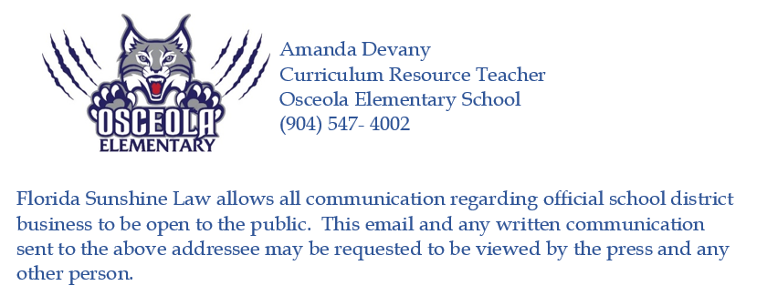



**Morning Drop Off/Afternoon Pick Up - Friendly reminders**

*In order to make the arrival and dismissal time as safe as possible please adhere to the following reminders and timeline for parent pick up and dismissal.*

**Arrival Procedures (7:55-8:20)**

**8:20** – 1st bell rings.

* Double doors by the parent drop off loop close and will be locked.
* School personnel go inside.
* Students arriving after 8:25am will be walked into the office and

signed in by an adult.

**8:25** – 2nd bell rings. School day begins.

* **It is against the law to text or talk on the phone in a school zone.** This is also a safety concern for your children and our staff members who are supervising the PPU/DO process.
* Parents will be signaled by an Osceola staff member when it is time for children to exit the vehicle at 7:55. Children should not exit the vehicle until signaled.
* Children should exit the vehicle from the passenger side of the car. This way staff and students are not in the lane with moving vehicles.
* The parent pick up lot will be locked at 8:25 each morning.
* If you arrive after 8:25, an adult will need to walk children to the front office.
  + Please do not allow children to walk into the building unescorted.
  + As you know, the front office has a buzzer button that children are not able to reach in order to alert staff that they are outside.
* If your PreK child is here after 8:20 you will take them to the front office where you will need to wait with them until PreK staff arrive to escort them to the classroom.
* If PreK students are not picked up by 2:40, you will pick them up from the office.
* Drivers should exercise safe driving habits when entering and exiting the Parent Pick Up lot.
* For afternoon pick up, student name tags should remain on the dashboard of the car until you have left the Parent Pick Up line.
* During afternoon pick up, PreK parents will move to the parking area or between the cones at the front of the parking lot while waiting for PreK siblings if they are not out when the second dismissal process begins.

**Dismissal procedures (2:40-3:10)**

* Use the parent pick up loop to pick up students.
* Parents remain in their cars to pick up children, otherwise they will be asked to report to the front office to check out their children.

la Simmons



**Friday, May 27th 2022**

**$80.00 per student**

**$80.00 per chaperone**

**Arrive at OES at 6:30 am**

**Depart OES at 7:00 am**

**Return to OES at 8:30pm**

**Each student will receive an all-day dining pass**

**Final Payment is due on or before Friday, April 8th**

**Please click on the link below to make your full or partial payment**

[**https://www.schoolpay.com/pay/for/5th-Grade-Seaworld--22-SECOND-PAYMENT-40/SY7kQE**](https://www.schoolpay.com/pay/for/5th-Grade-Seaworld--22-SECOND-PAYMENT-40/SY7kQE)

[**https://www.schoolpay.com/link/Seaworld-full-payment**](https://www.schoolpay.com/link/Seaworld-full-payment)





**Yearbook Ads and Messages**

We will now be selling ads for the 2022 yearbook. These are a great way to show your 5th grader how proud you are of them as you send them off to middle school!

**For students in 5th grade**, parents may purchase a ¼ page ad for $25.00. These ads can include a message of congratulations and a picture, or you may include a business card and a picture of your student. Pictures should be no larger than a wallet size and will not be returned.

**For students in Pre-K-4th grades**, parents may purchase a one-line message for $10.00. These messages must be limited to no more than 25 words.

All payments must be payable to **OSCEOLA PTO** and the **deadline to order these is by end of the school day on Friday, February 25th.**

Please complete the form below and return in a sealed envelope with your child.

----------------------------------------------------------------------------------------------------------**YEARBOOK ¼ PAGE AD:**

**Cost: $25.00**

I have enclosed $25.00 and my ad is written below:

_____________________________________________________________________________________________________________________________________________________________________________________________________________________________________________________

Student’s Name:_________________Teacher:______

Parent’s Name:______________________________ Telephone#:_________________________

----------------------------------------------------------------------------------------------------------**Message: (25 word limit)**

**Cost: $10.00**

I have enclosed $10.00 and my message is written below:

**____________________________________________________________________________________________________________________________________________________________________**

**Upcoming Events**



**February 22nd:** Class Pictures

**February 23rd:**Early Release Wednesday

**February 25th:** Boosterthon Fun Run

**March 1st:** SAC/PTO Meeting 5:30 pm

March 1, Character Counts Celebration, Wear Red

**March 2nd:** Early Release Wednesday

**March 9th:** Early Release Wednesday

**March 10th:** Third Quarter Ends

Spring Social

**March 11th:**Teacher Planning Day – Student Holiday

**March 14th – 18th:**Spring Break – Student/Teacher Holiday

**March 21st:** Classes Resume for Students

**Extended Day Registration 2019-2020**

**Extended day registration for 2019-2020 can be found on the OES website. Registration form and fee are due on or before Tuesday, April 30th to secure a spot. All VPK Extended day spots have been filled for the 2019-2020 school year.**

|  |
| --- |
|  |



*2/21/22     Monday    NO SCHOOL*

*2/22/22     Tuesday     MINI CORN DOGS / NACHO LIL BITES*

*2/23/22     Wednesday  CHICKEN SANDWICHES*

*2/24/22     Thursday    PIZZA  - CHEESE OR PEPPERONI*

*2/25/22     Friday         CHEESE BURGERS*

*Cool Boxes served as an option daily*

*ALL Meals are served with choice of:*

*HOT VEGETABLE or ASSORTED FRESH*

*VEGGIE*

*ASSORTED FRESH FRUITS*

*MILK*

***1/31/22   Monday        CHICKENNUGGETS***

***2/1/22     Tuesday        MINI CORN DOGS***

***2/2/22   Wednesday  CHICKEN SANDWICHES***

***2/3/22    Thursday      PIZZA***

***2/4/22   Friday            CHEESE BURGERS***

***Cool Boxes available everyday***

**THANK YOU FOR GETTING YOUR   
STUDENT TO SCHOOL ON TIME   
EACH DAY.**

**Students must be in   
their classrooms by 8:25 AM.   
  
THANK YOU FOR LIMITING EARLY   
CHECKOUTS WHEN POSSIBLE**

**to   
ensure that classroom instruction   
time is not disrupted**