Pre-K Supply List
21-22

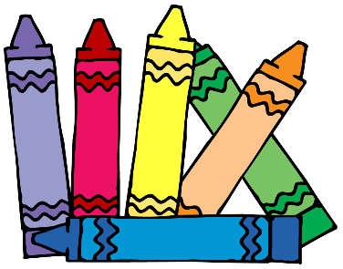

- Backpack (regular size, the small one’s are difficult to fit a folder in)
- Small Blanket or Towel (labeled with child’s name)
- 1 box Crayola crayons (24 pack)
- 1 box washable markers (12 pack)
- 1 boxes of tissues
- 2 rolls of paper towels

Optional:
2 packages of baby wipes

Also, please send in an extra set of clothing (including socks and underwear) in a labeled Ziplock bag.

