Pre-K Supply List

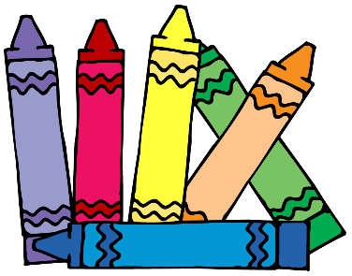

- Backpack
- Small Blanket or Towel (labeled with child’s name)
- 1 box Crayola crayons (24 pack)
- 1 box washable markers
- 2 boxes of tissues
- 2 rolls of paper towels
- 1 package of paper lunch bags

Optional:
2 packages of Clorox Wipes

Also, please send in an extra set of clothing (including socks and underwear) in a labeled Ziplock bag.

