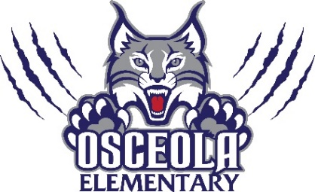
Parent Teacher Organization
Meeting Agenda
November 1st at 6:15pm
- Budget Update –
- Seaside Dentistry and World Golf Hall of Fame- Follow-up Recognition for Sponsorship
- Playground Improvements- covers and volleyball field Mr. Strickland does not know of any specific requirements that we need to follow.
- Movie Night Screen- update from Tina Waldrop after reaching out to other Title 1 schools
- Scholastic Book Fair: 11/14-11/18 Classes will visit during media resource time
  - Set up 11/10
  - Read and Feed 11/15
  - Grand’s Breakfast 11/16 (food sponsored by KFC)
  - Thanksgiving Luncheon Pre-K-2 11/17
  - Pack Up 11/18
- Holiday Shop (1st Place Fundraising) 12/12-12/16
- Sonny’s Spirit Night: Dec. 13th from 5-8 pm
- Winter Lunch for Teachers and Staff back to school on Jan. 5 or 6 luncheon.
- Literacy Week- Jan. 23rd-27th
  - Read-a-thon
  - Guest Readers/Authors
  - Movie/Carnival Night
- Dad’s Breakfast Feb. 9th
- Sweetheart Social Feb. 16th
- Chick-fil-a Spirit Night Feb. 23rd
- Open Floor/Questions/Comments

Next Meeting December 6th following SAC

