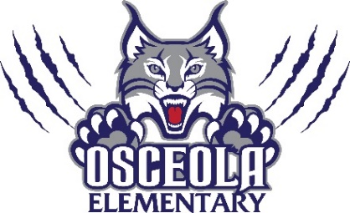
Parent Teacher Organization
Meeting Agenda
October 4th at 6:15pm
- Budget Update –
- Book Adventure introduction for parents
- Seaside Dentistry and World Golf Hall of Fame- Follow-up Recognition for Sponsorship
- Playground Improvements- covers and volleyball field
- Movie Night Screen
- Current PTO Fundraiser- 9/30-10/15 Home Goods/ Wrapping Paper
- Current “Box Top Tournament”- 10/3-10/21 Top three collectors will be awarded.
- Chick-Fil-A Spirit Night: 10/20
- Scholastic Book Fair: 11/14-11/18
  - Read and Feed 11/15
  - Grand’s Breakfast 11/16 (food sponsored by KFC)
  - Thanksgiving Luncheon Pre-K-2 11/17
- Holiday Shop (1st Place Fundraising) 12/12-12/16 Schedule for classes
- Sonny’s Spirit Night: Dec. 13th from 5-8 pm
- Winter Lunch for Teachers and Staff back to school on Jan. 5 or 6 luncheon.
- Literacy Week- Jan. 23rd-27th
  - Read-a-thon
  - Guest Readers/Authors
  - Movie/Carnival Night
- Dad’s Breakfast Feb. 9th
- Sweetheart Social Feb. 16th
- Chick-fil-a Spirit Night Feb. 23rd
- Open Floor/Questions/Comments
Next Meeting November 1st following SAC

